**1. Congratulations!**

You did it! Congratulations on completing this course. You've now got a strong understanding of the foundations of SQL.

**2. What you've learned**

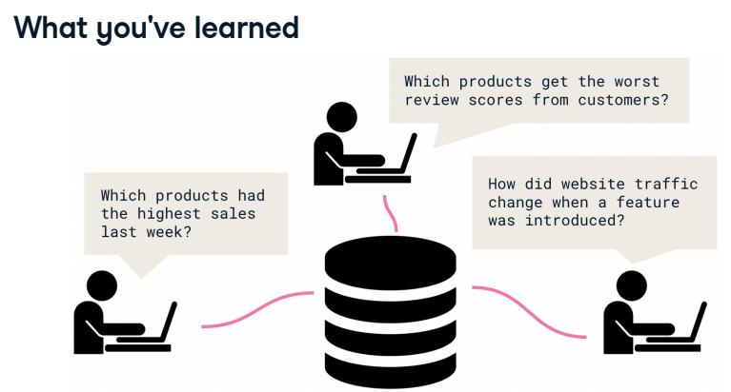You've learned when and why databases are useful,

**3. What you've learned**

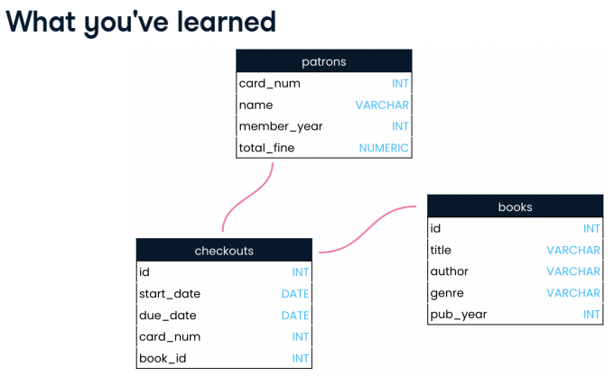you've navigated the organization of relational databases,

**4. What you've learned**

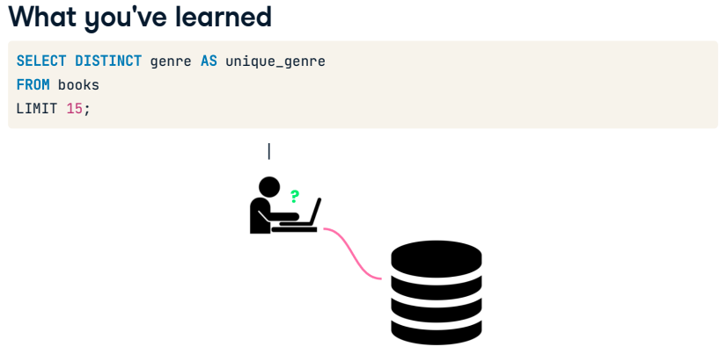and you've written your own SQL queries to extract insight from a database.

**5. Where to go next**

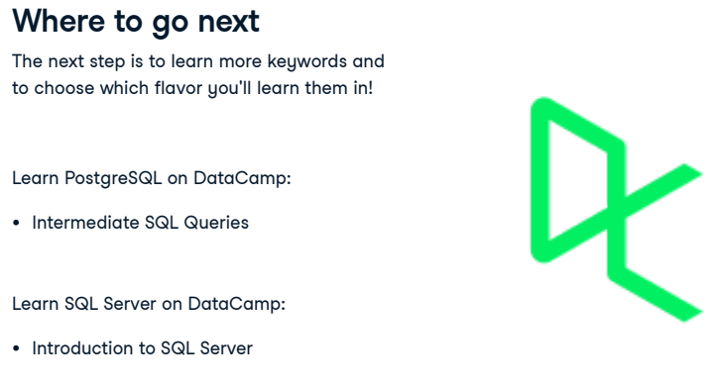From here, it's only a matter of learning more keywords before you're writing complex SQL queries! As we discussed, the keywords you learned in this course are shared between SQL flavors, and that is true of most keywords. However, given the small differences between flavors, the next course you take will be specific to a SQL flavor. Here are a few DataCamp courses that you may want to take next.

**6. Thank you!**

No matter where you take your new SQL knowledge, thanks for taking this course all the way to the end! And congratulations again on a successful start to your SQL journey!